GAMEZONE REPORT
Gamezone is a multinational e-commerce company specializing in consumer electronics, with operations spanning multiple countries and digital sales platforms. The company leverages comprehensive transaction, logistics, and marketing data to inform strategic decisions, optimize performance, and enhance operational efficiency.
The areas that will inform our insights and recommendations include:
Sales trend analysis: sales growth rate (SGR), average order value (AOV), revenue per visitor (RPV).
Product performance.
Regional Performance: total sales revenue/sales by region, product performance by revenue.
Gamezone’s dataset structure consists of 11 rows with a total column count of 21865.
Here is a link to the interactive excel dashboard
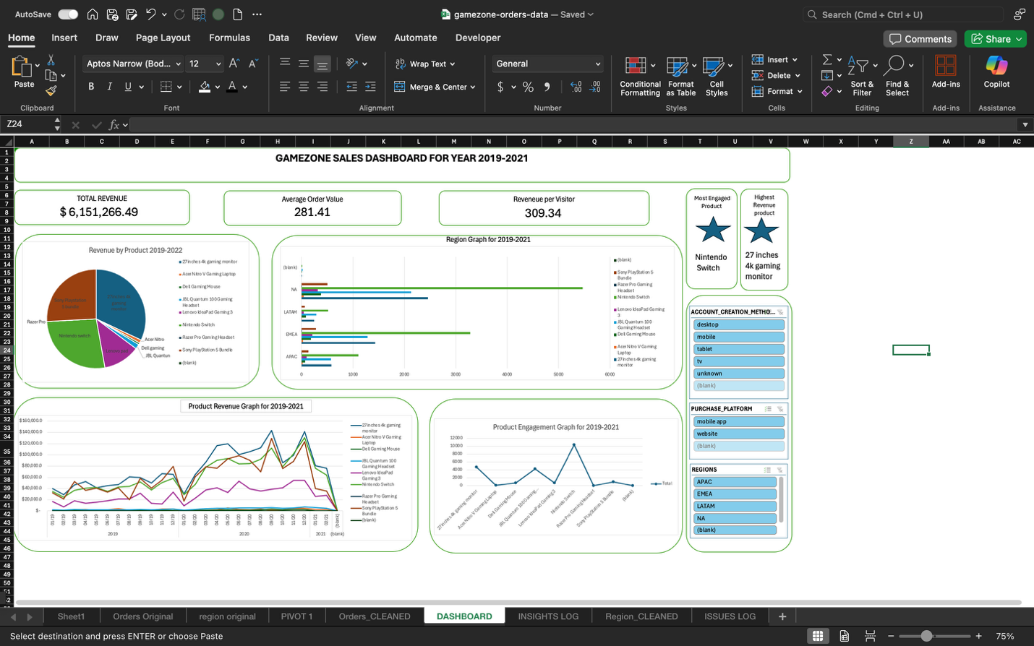
Overview of findings
There was a 99.9% increase in the total sales growth rate between 2019 and 2020 this may be largely due to the pandemic and its effect on ecommerce; with the top performing products being the 27 inches 4k gaming monitor responsible for 32% total revenue, the Nintendo Switch accountable for 26.9% of total revenue and the Sony PlayStation Bundle with 25.8% of total revenue.

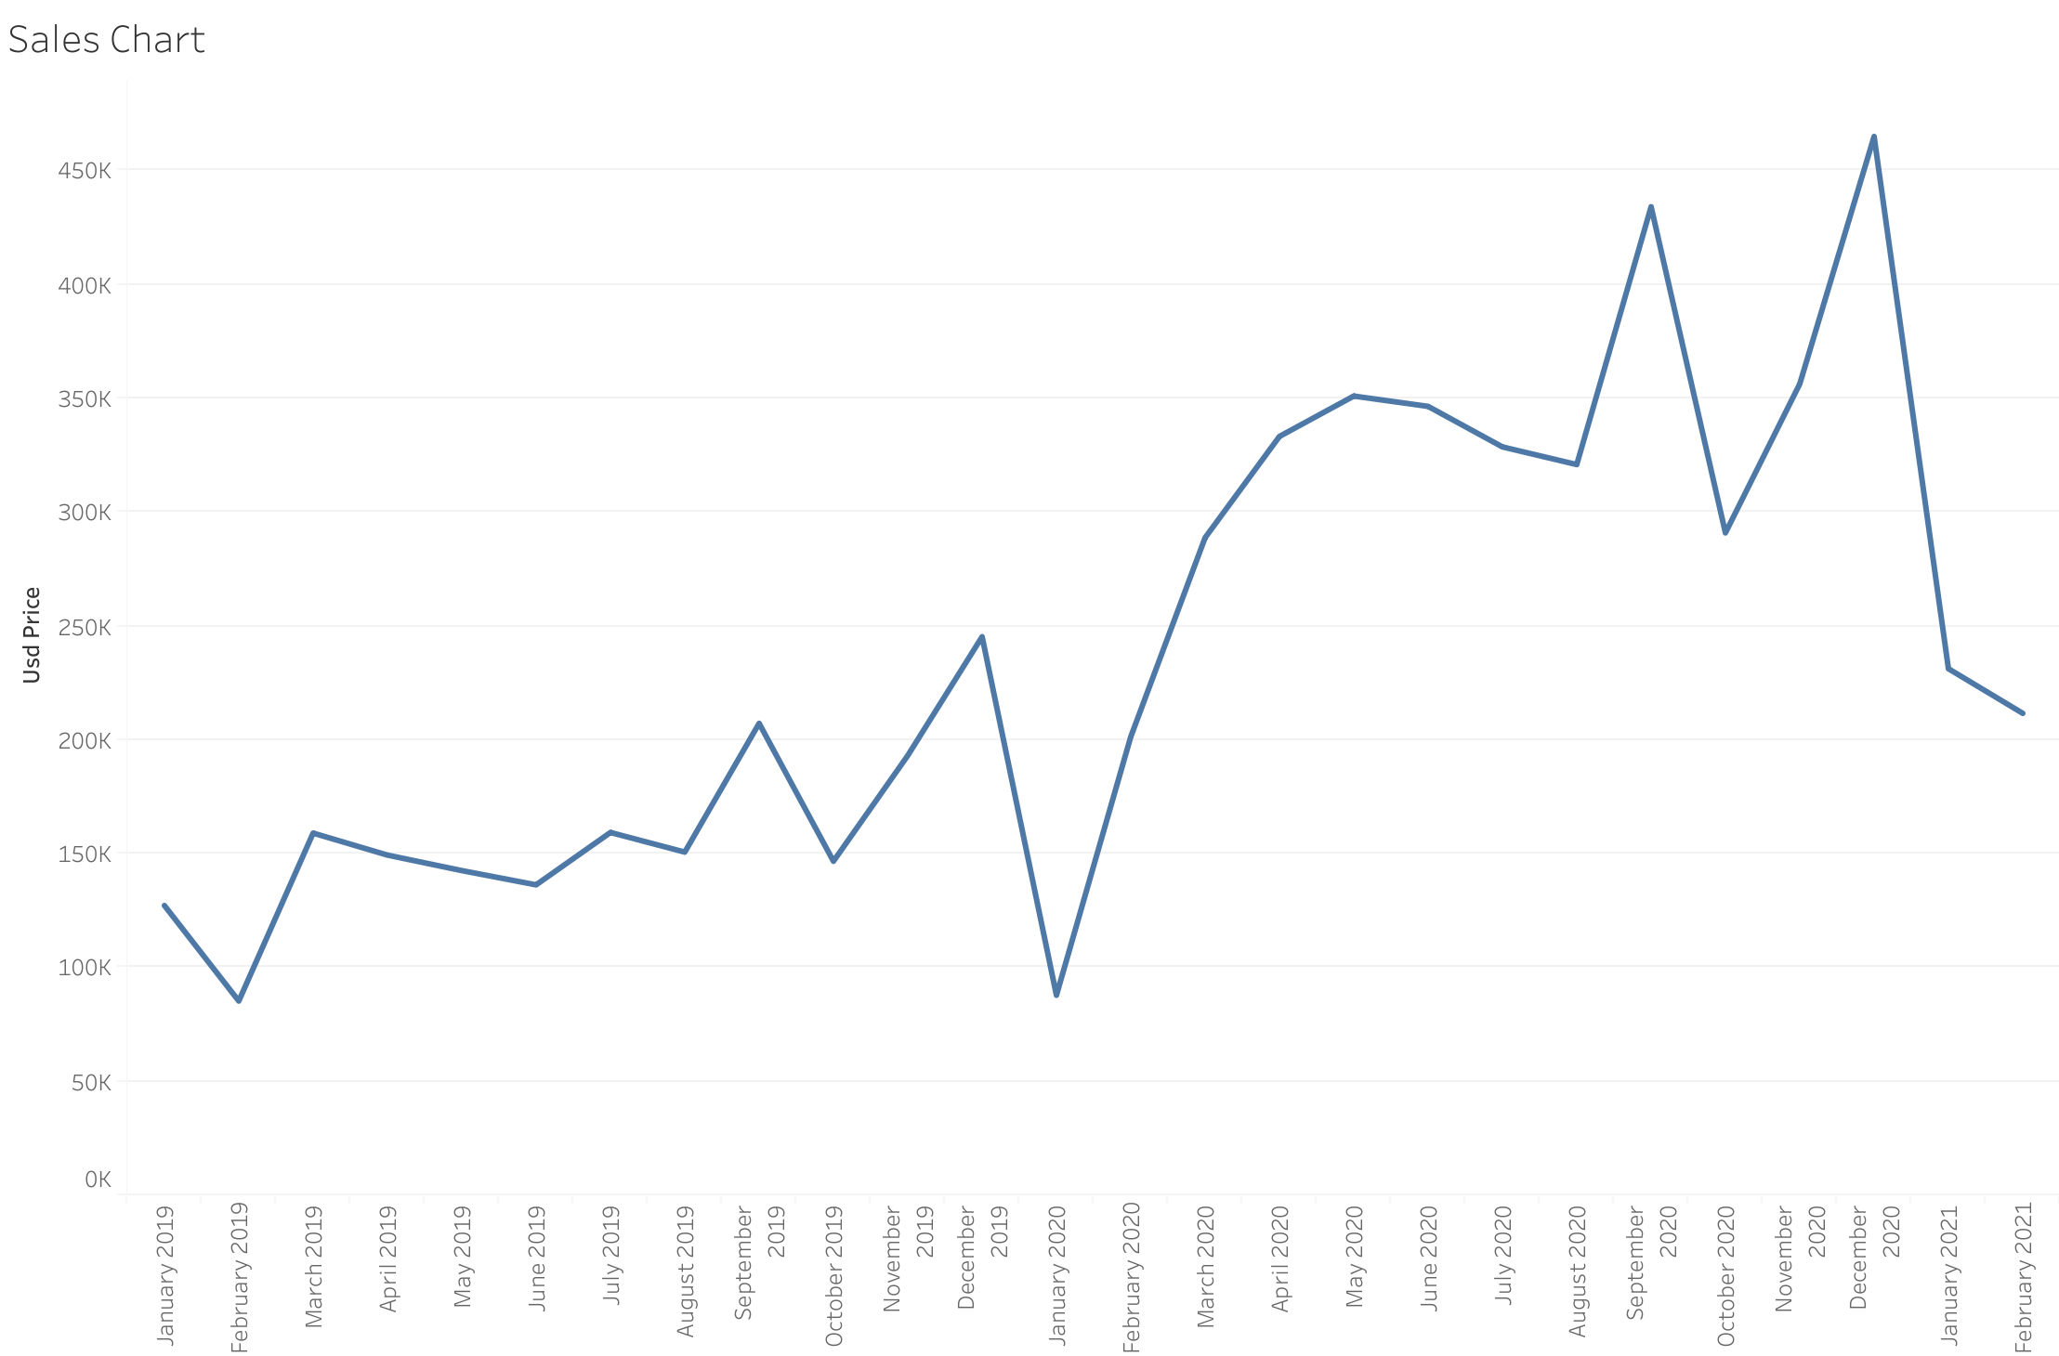

The highest sale recorded was in November/December 2020. The beginning of 2021 recorded a sharp decrease which is on par with pre-pandemic period (Jan 2020). Nearly all the products seem to record an increase toward the end of each year which may be due to promotions during festivities. October each year records a sharp decline for nearly all products.

The Average order value (aov) is 281 and the revenue per visitor is 309 which indicate a positive strategy outcome, we should track this aov and compare to future aov to make sure we are continuously on the right track.

North America Region accounted for 52% of total revenue followed by the Europe. Middle east and Africa (emea) region with 30%. The regions record a sharp decline in January 2020 which is in line with the decline all the products recorded at the start of the pandemic; this followed by consistent rising sales, all regions also experienced another sharp drop on October before ending the year strongly with high numbers; and as with every January since 2019, there was a drop in sales .

The Nintendo switch is the best performing product across all regions. The success of the Sony PlayStation can be attributed to the price of the product as well as the other offers in the bundle.
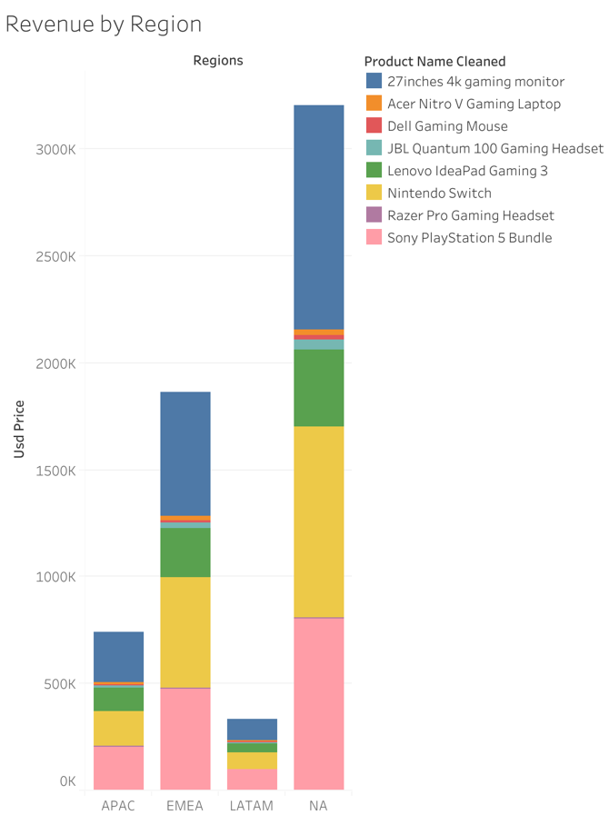

Recommendation
- Even at the height of e-commerce success and promotions the lowest performing products struggled to record any real progress, we need to focus on upselling those products maybe consider bundling up to increase value.
- Promotions aimed at targeting and correcting the beginning of the year decline.
- We can personalize product recommendations based on purchase patterns by first tailoring it to region and then offering bundling or complementary products depending on high purchase count per each region.
- Segment customer by spending behavior and target customers with recommended purchases by other customers in the same segment.
Gamezone as a company is on the right track and just needs to focus on improving repeat purchases, higher margin add-ons and targeting struggling products across regions.

